Owner Lead Inquiry Workflow Walkthrough

1. Introduction to the Workflow 0:00
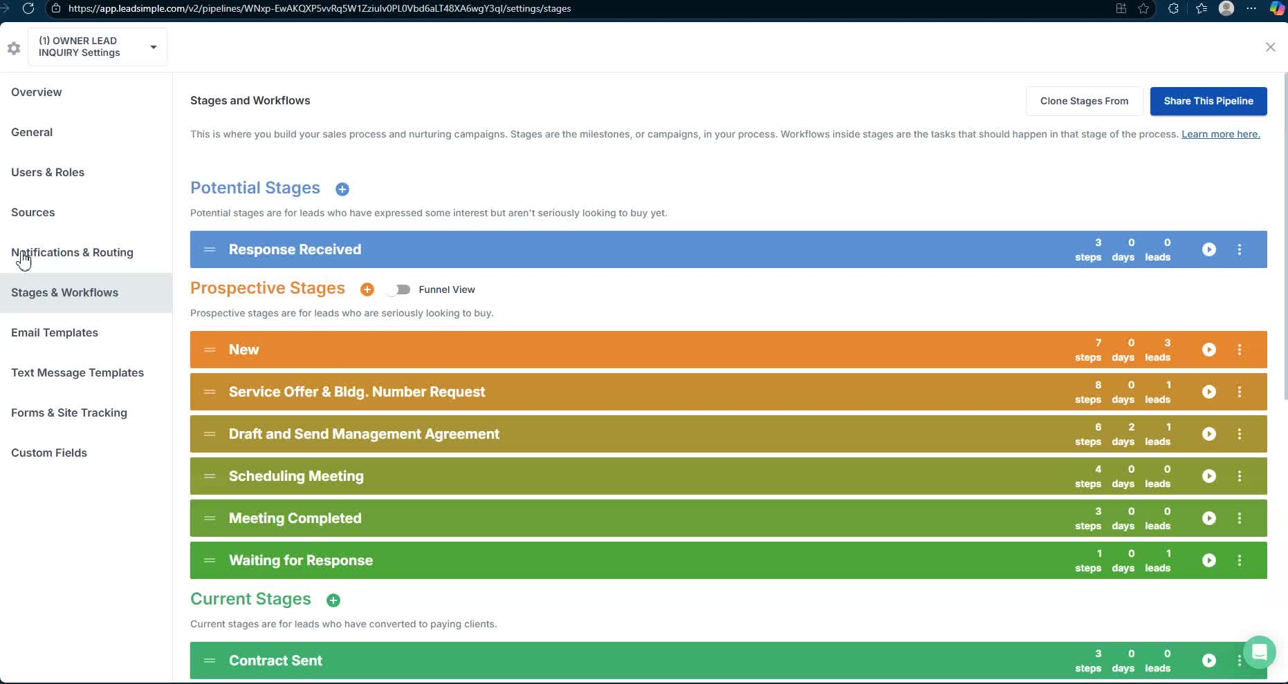
- Overview of the Owner Lead Inquiry workflow.
- Importance of managing the funnel accurately to avoid missing data and key steps.
- Aim for 99% accuracy as the standard for future growth.

2. Initial Inquiry Response 1:19
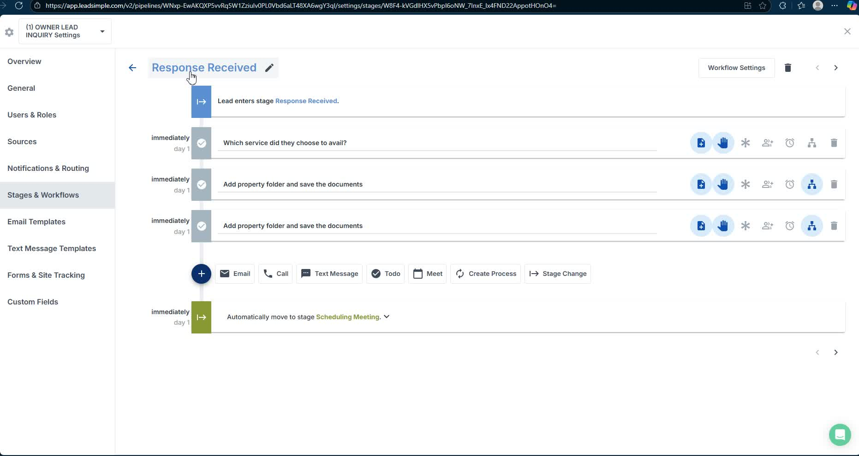
- Identify which service the owner is interested in (full management or lease only).
- Use the owner's form in Podio to gather initial information.

3. Collecting Owner Information 2:15
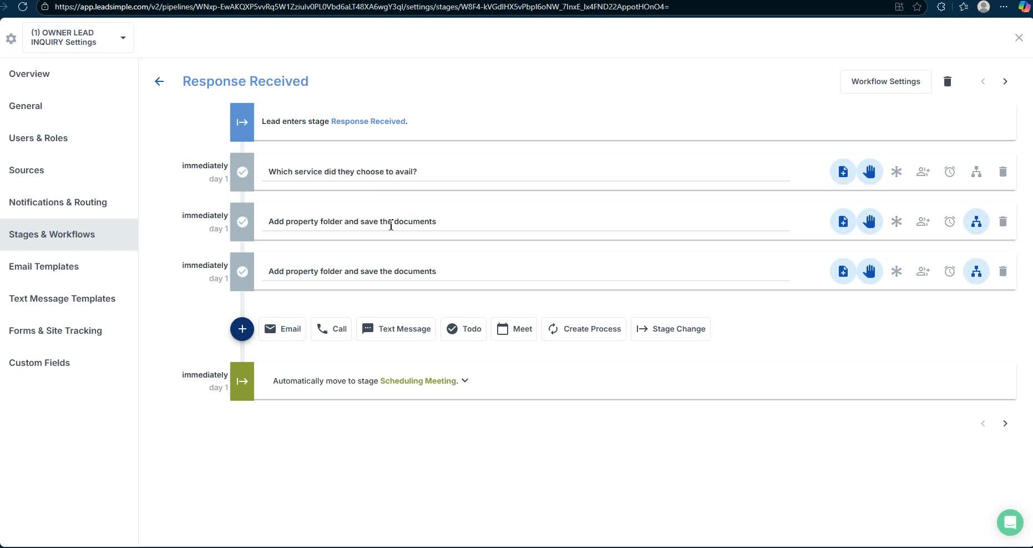
- Add property to the folder based on the service type (L for lease only, B for full management).
- Collect necessary documentation for verification of ownership (e.g., void check, insurance).

4. Scheduling a Meeting 3:52
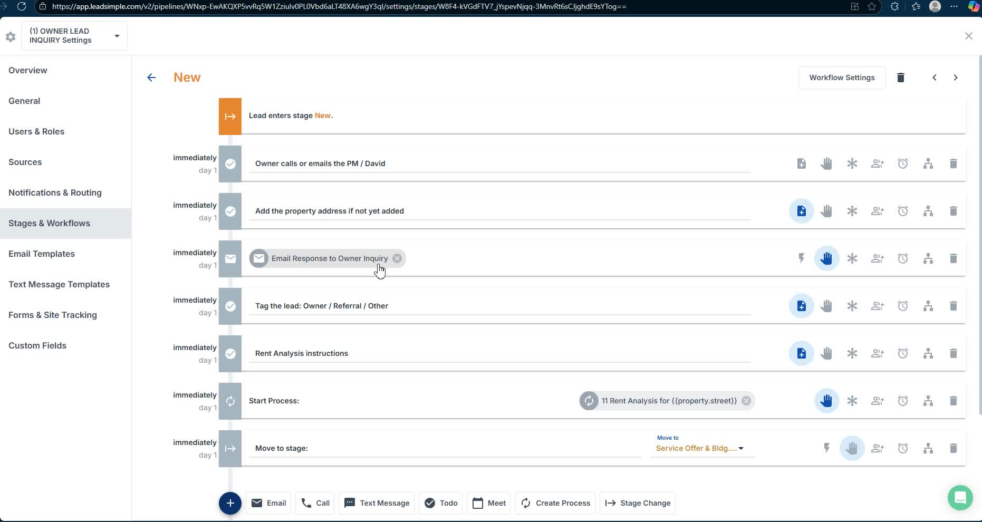
- Owners typically reach out via calls, emails, or referrals.
- Use Leadsimple to collect lead information and schedule a meeting.

5. Acknowledging Receipt of Inquiry 4:55
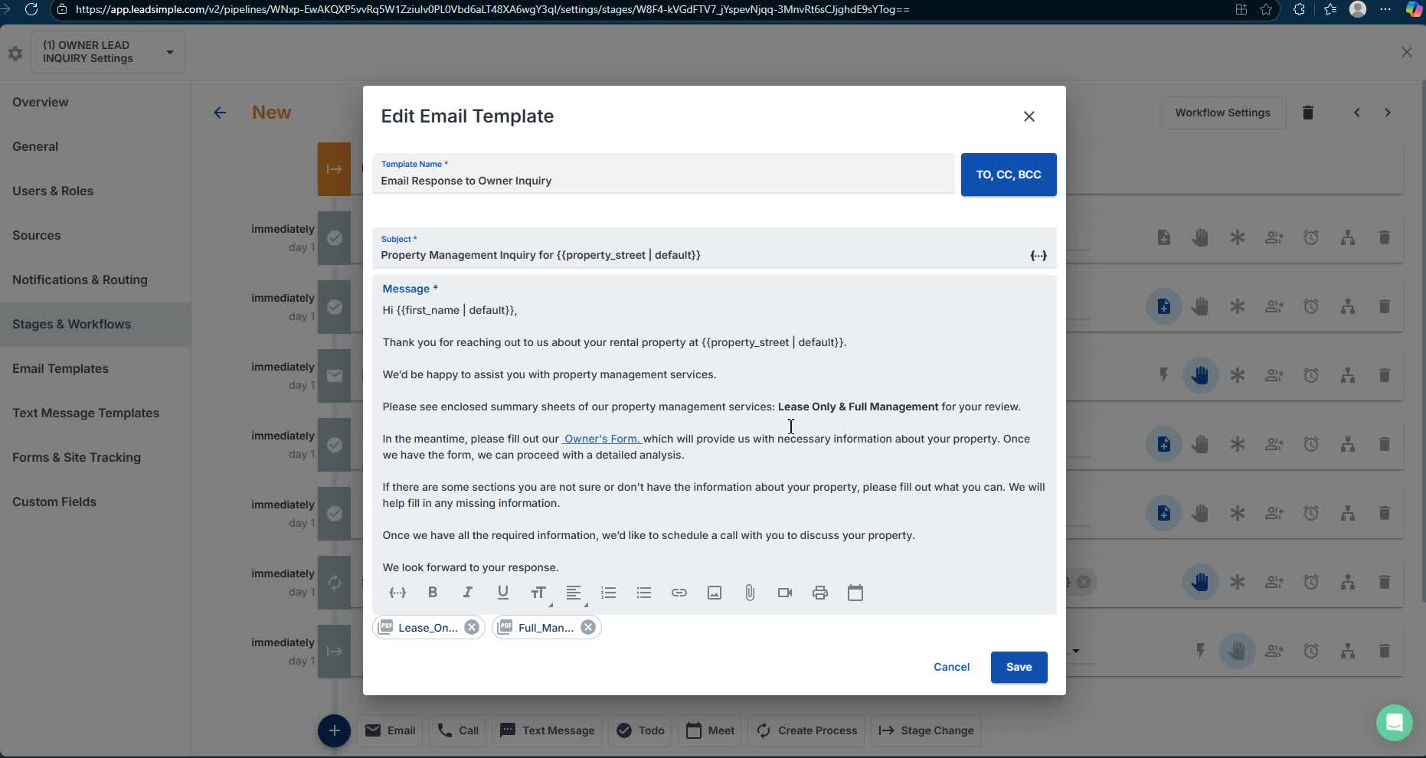
- Send an email template acknowledging the inquiry.
- Provide an overview of services and link to the owner's form.

6. Assisting with Owner's Form 5:46
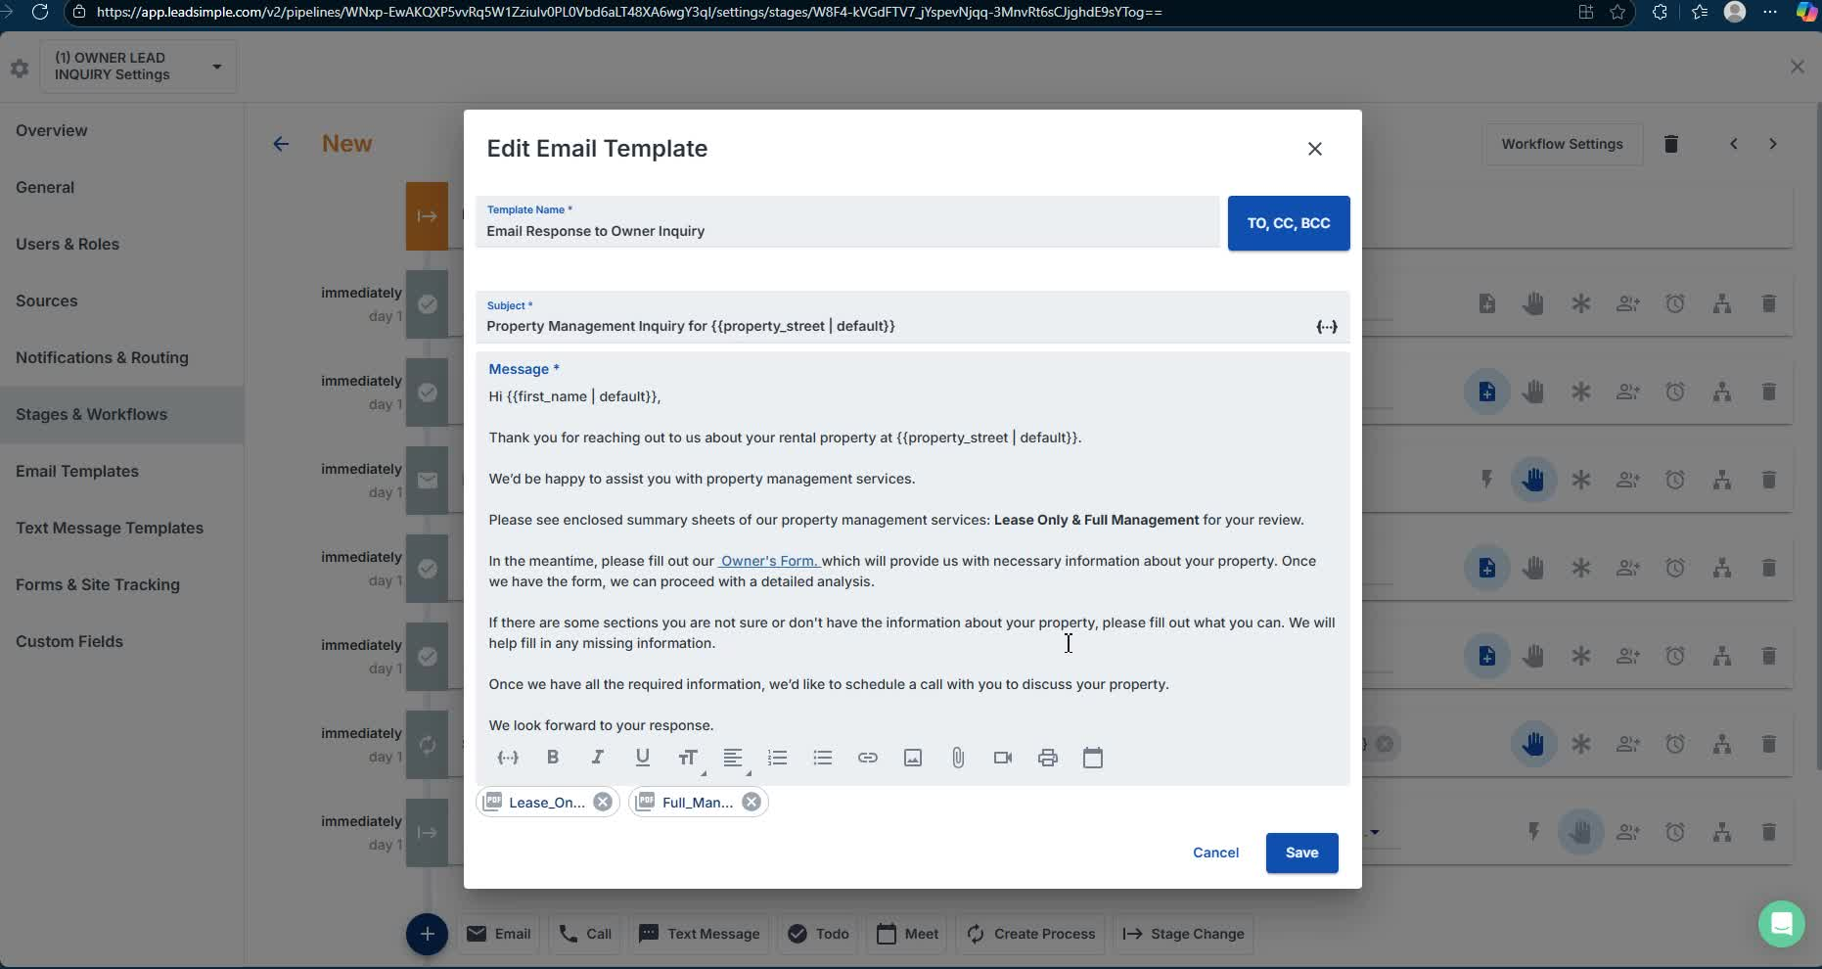
- Address common issues with form submission (e.g., mandatory fields).
- Encourage owners to fill out as much as possible.

7. Tagging the Lead in Leadsimple 7:11
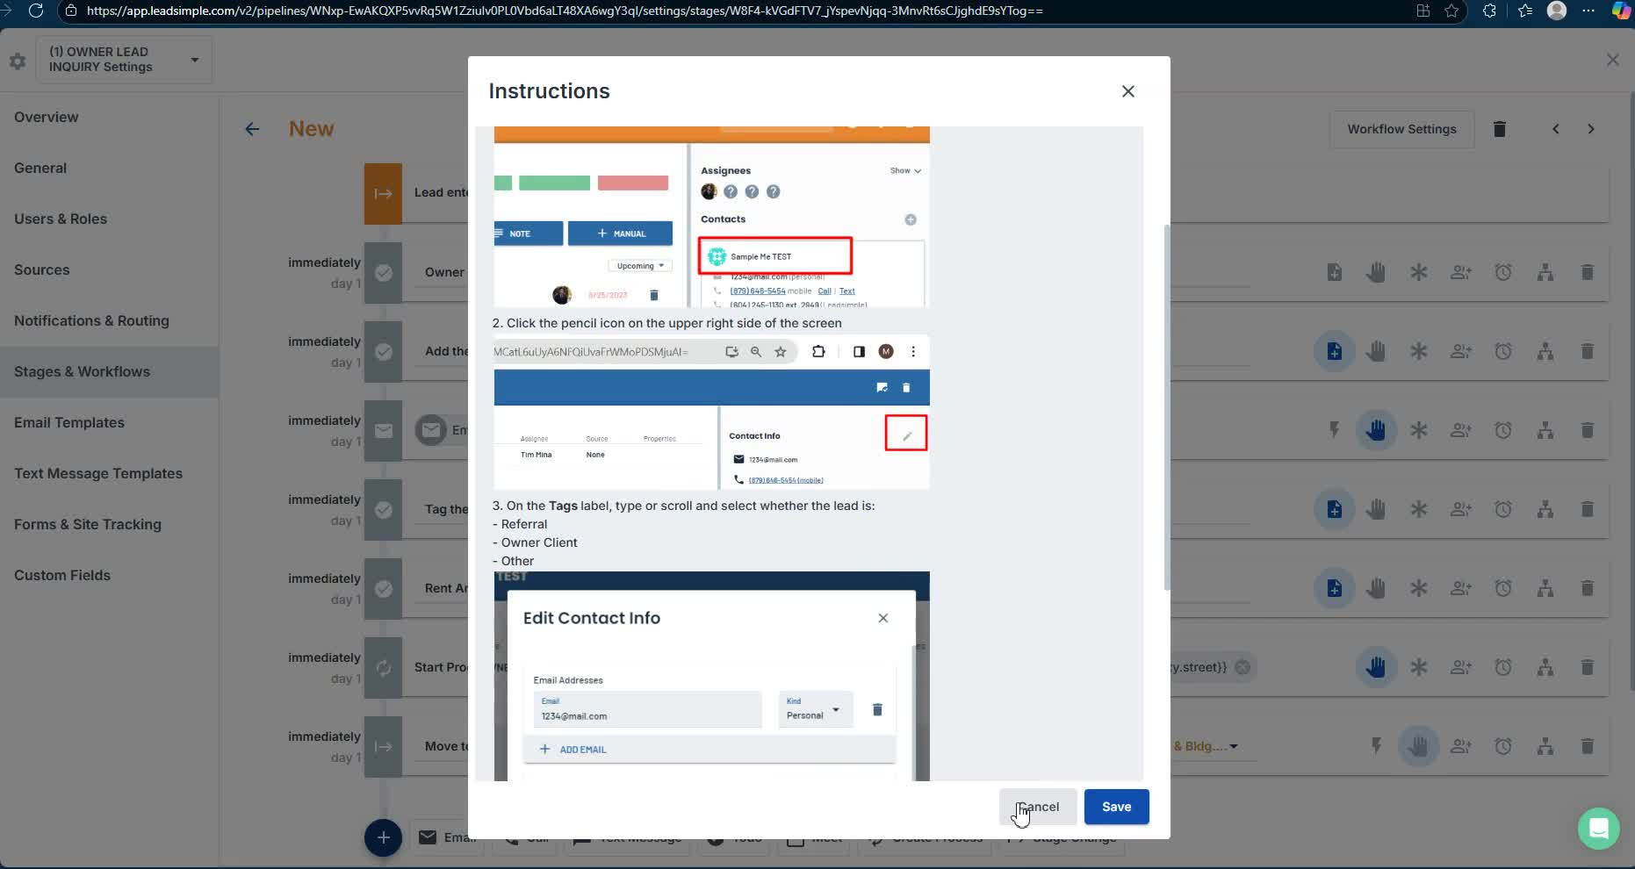
- Manually enter lead information into Leadsimple by the PMA team.

8. Conducting Rent Analysis 7:26
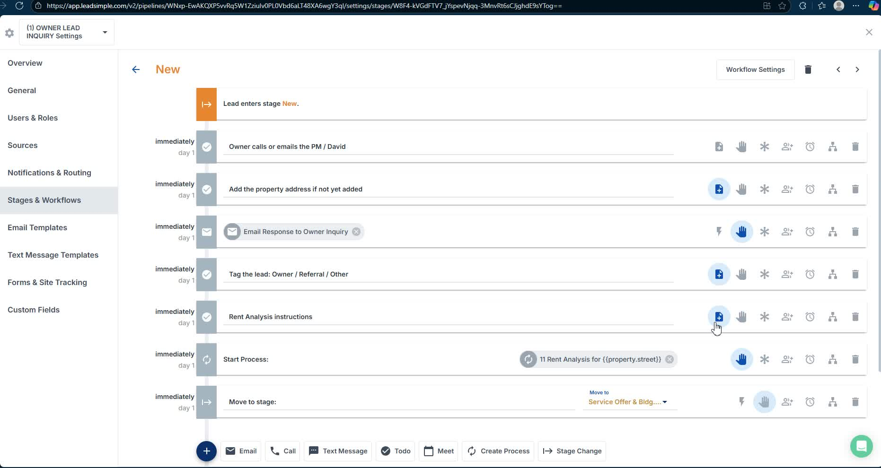
- Perform a rent analysis to understand property value.

9. Customizing Communication Templates 8:12
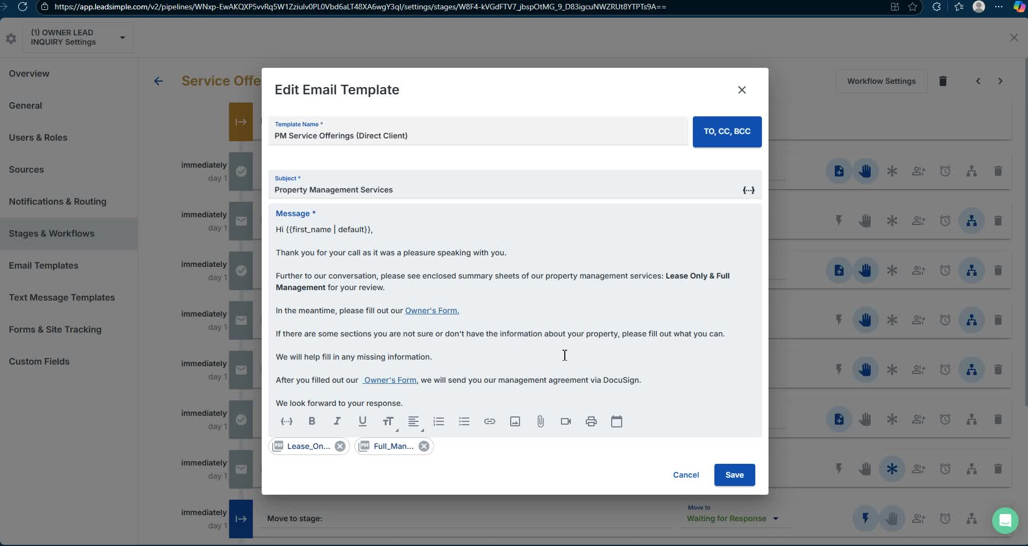
- Use templates for communication while ensuring they are customized for each scenario.

10. Acknowledging Referrals 9:04
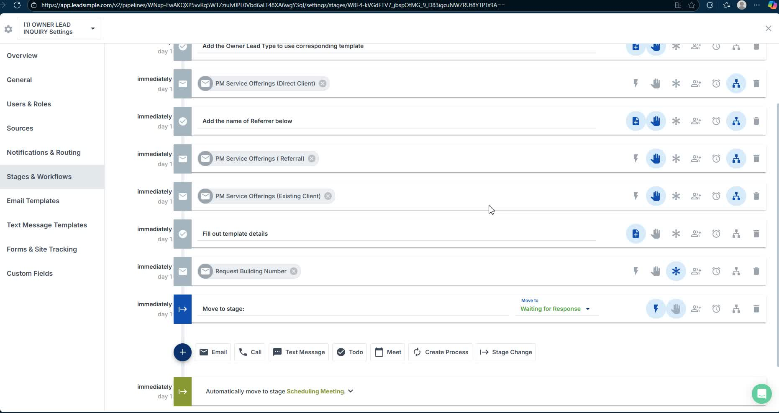
- Always acknowledge the referrer in communications to maintain relationships.

11. Requesting Building Number 10:30
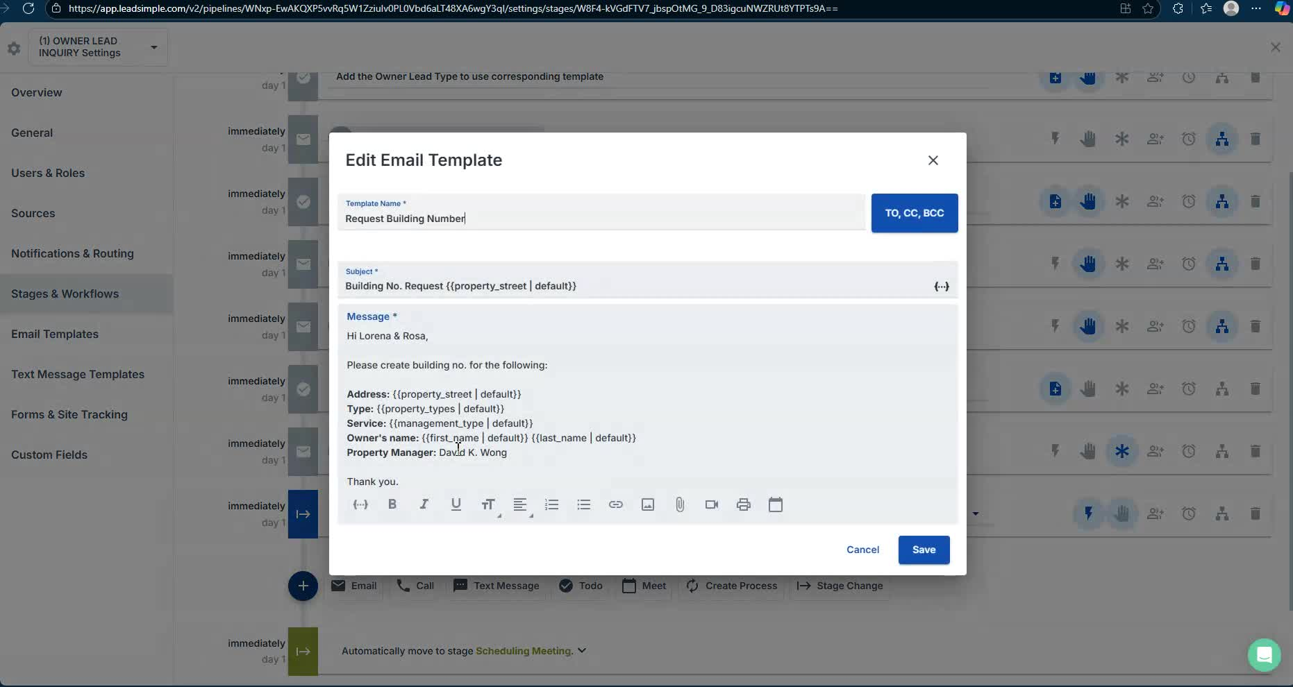
- Use a default email template to request the building number from the owner.

12. Meeting with the Owner 11:09
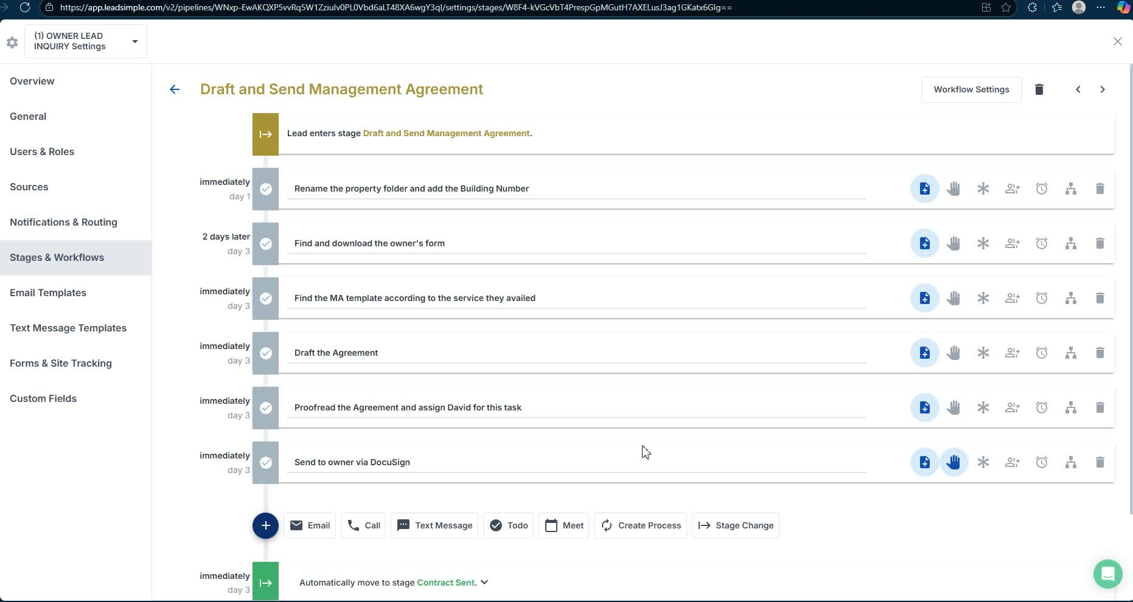
- Schedule a meeting to visit the property and understand its condition.

13. Property Inspection 14:10
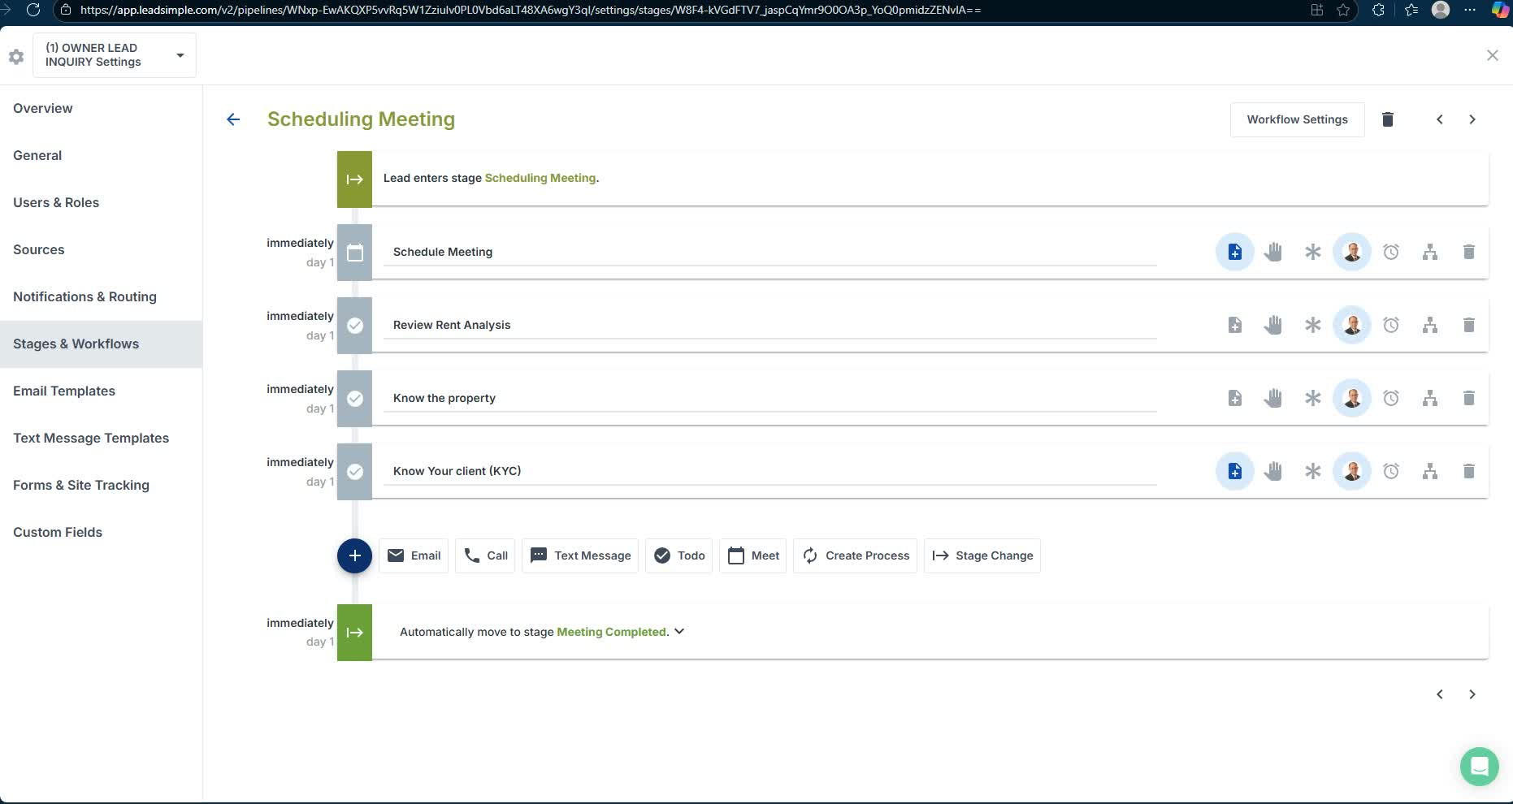
- Conduct a thorough inspection of the property to assess its condition and maintenance needs.

14. Drafting the Management Agreement 15:32
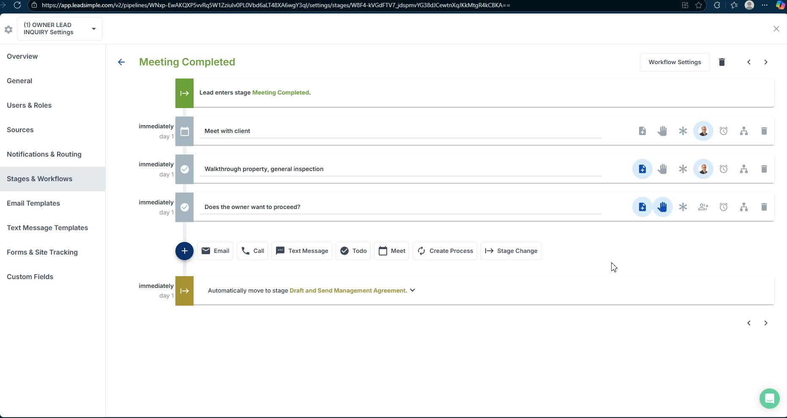
- Finalize and send the management agreement to the owner for signing.

15. Submitting Documentation to Back Office 16:13
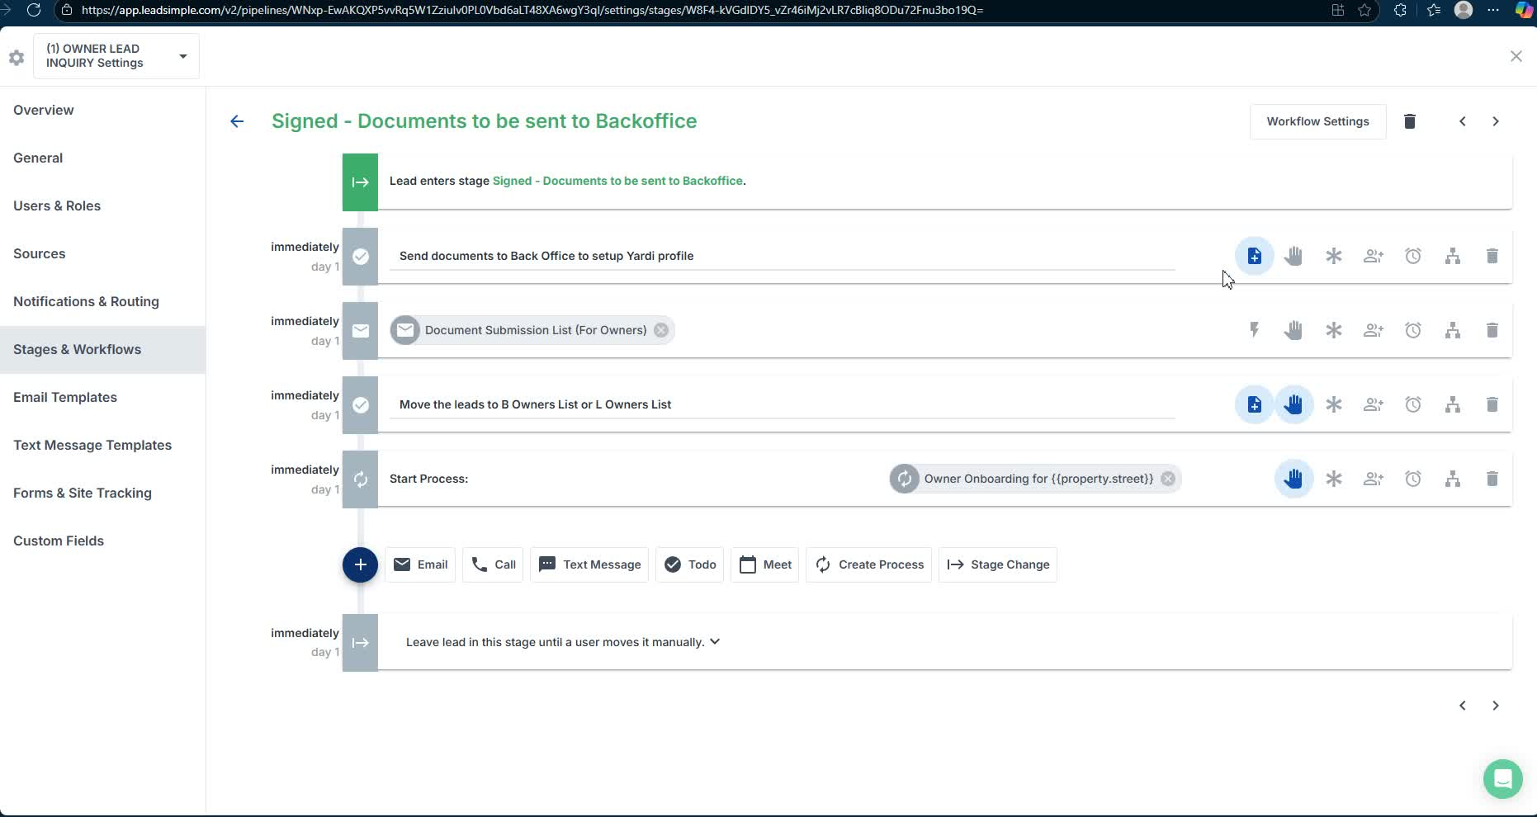
- Compile and submit necessary documents for back office processing.

16. Owner Onboarding 20:32
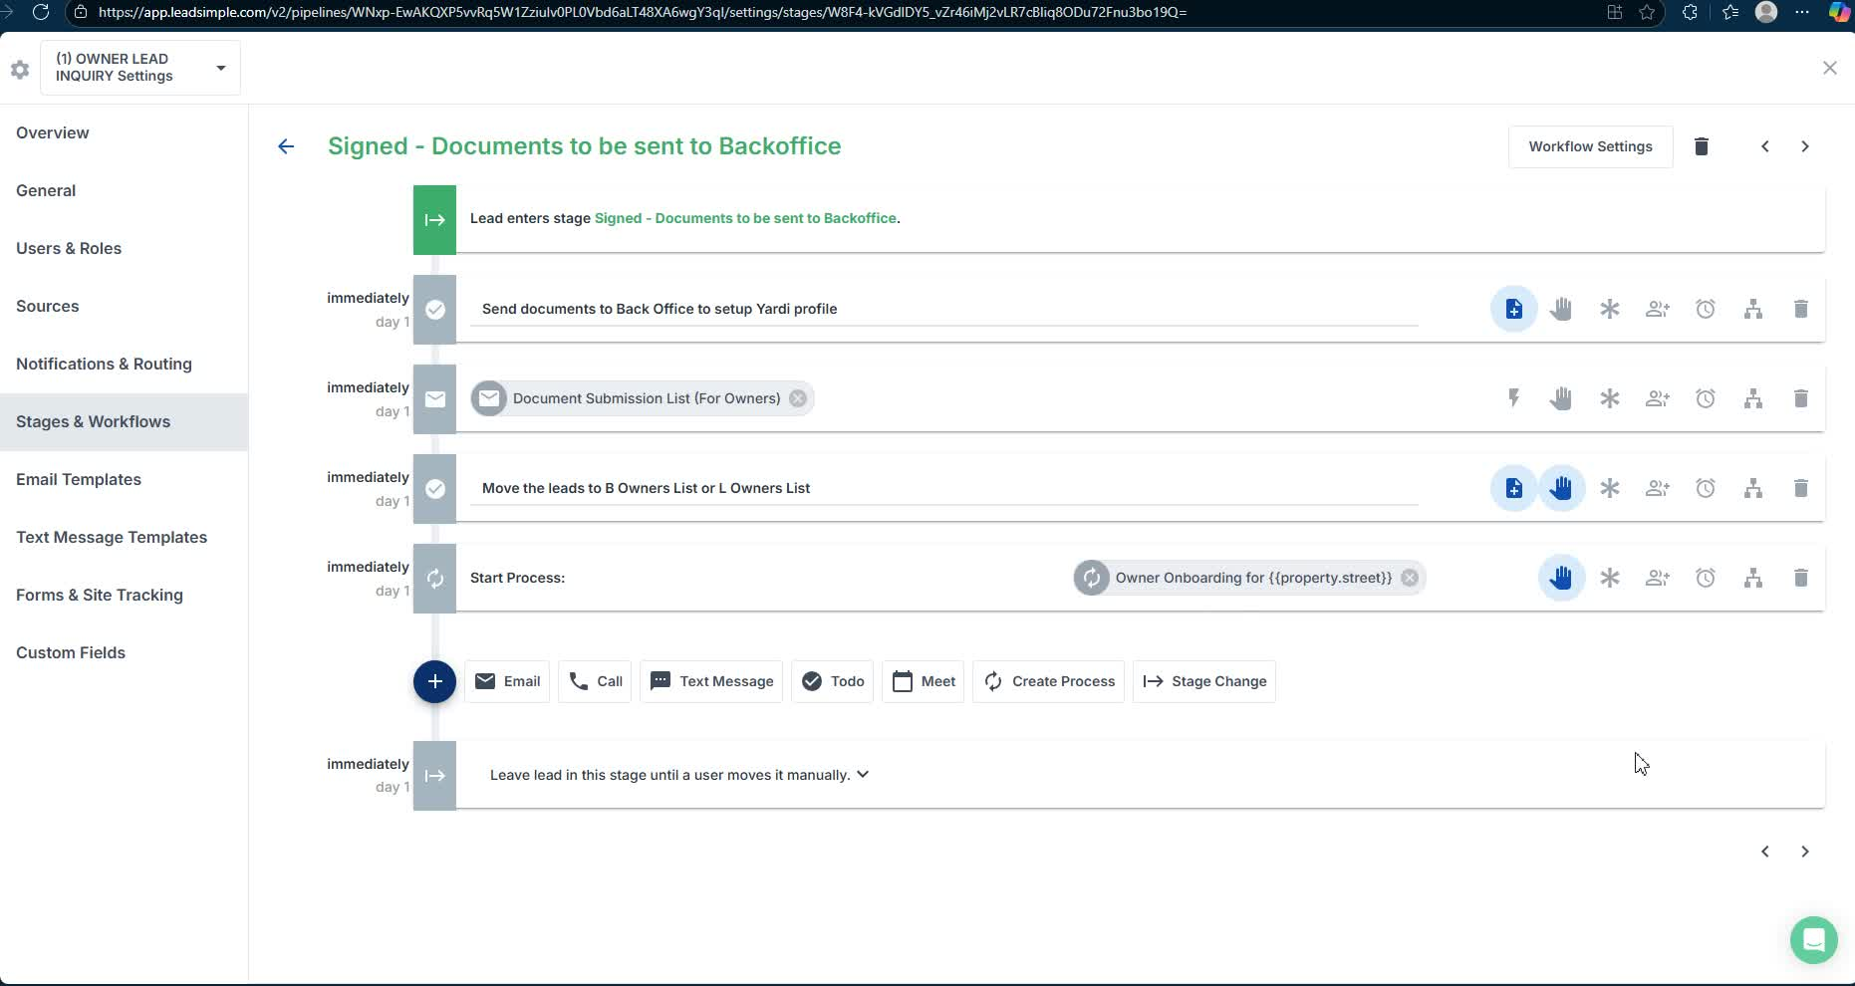
- Begin the onboarding process for the owner once all documentation is complete.

17. Handling Non-Proceeding Owners 20:47
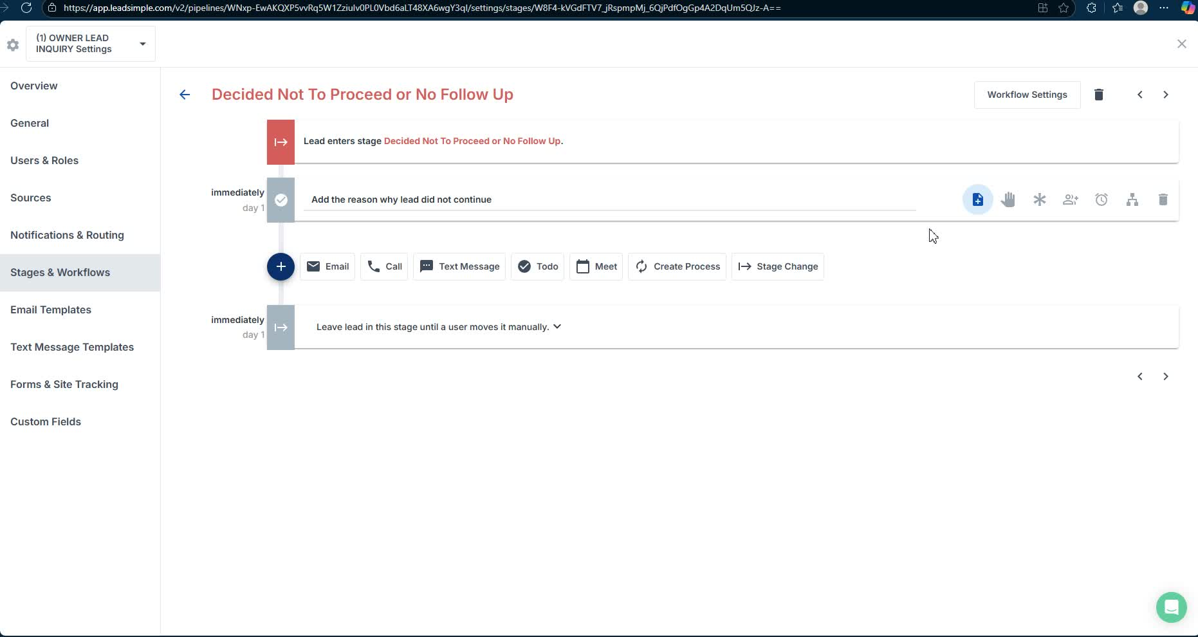
- Document cases where owners decide not to proceed and close the inquiry in Leadsimple.
Link to Loom
https://loom.com/share/c2511769dbac458b9ef070f74291bd3c

Steps to Reproduce Owner Lead Inquiry Bug

1. Initiate Owner Inquiry 4:04
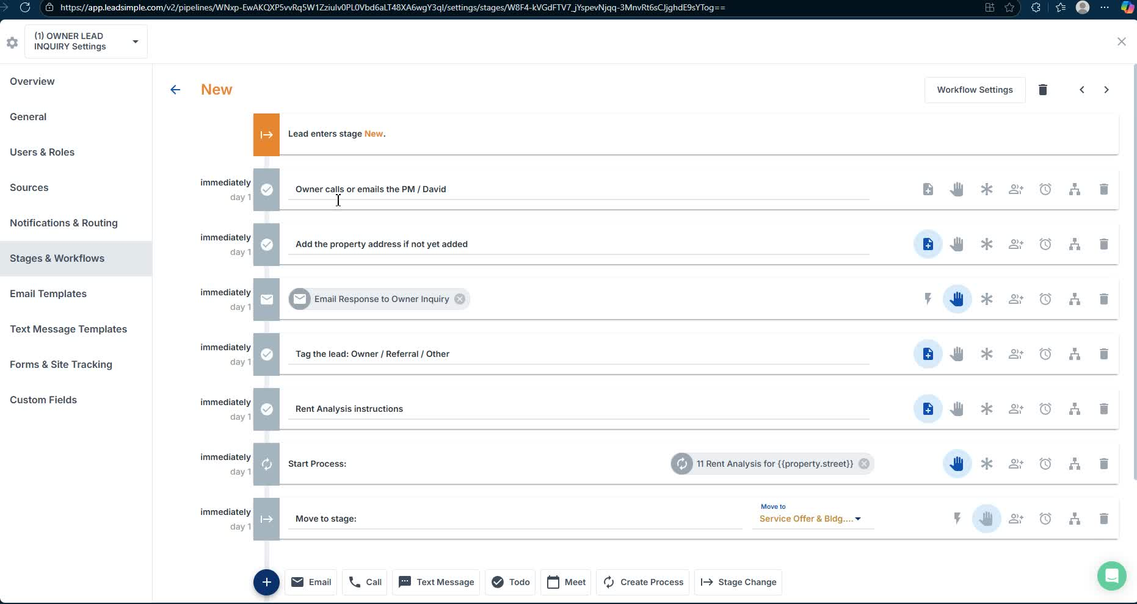
- Owner contacts via phone, email, text, or referral.
- Collect initial information using Leadsimple.

2. Send Acknowledgment Email 4:55

- Use the template to acknowledge receipt of inquiry.
- Include a link to the owner's form for further details.

3. Complete Owner's Form 5:09
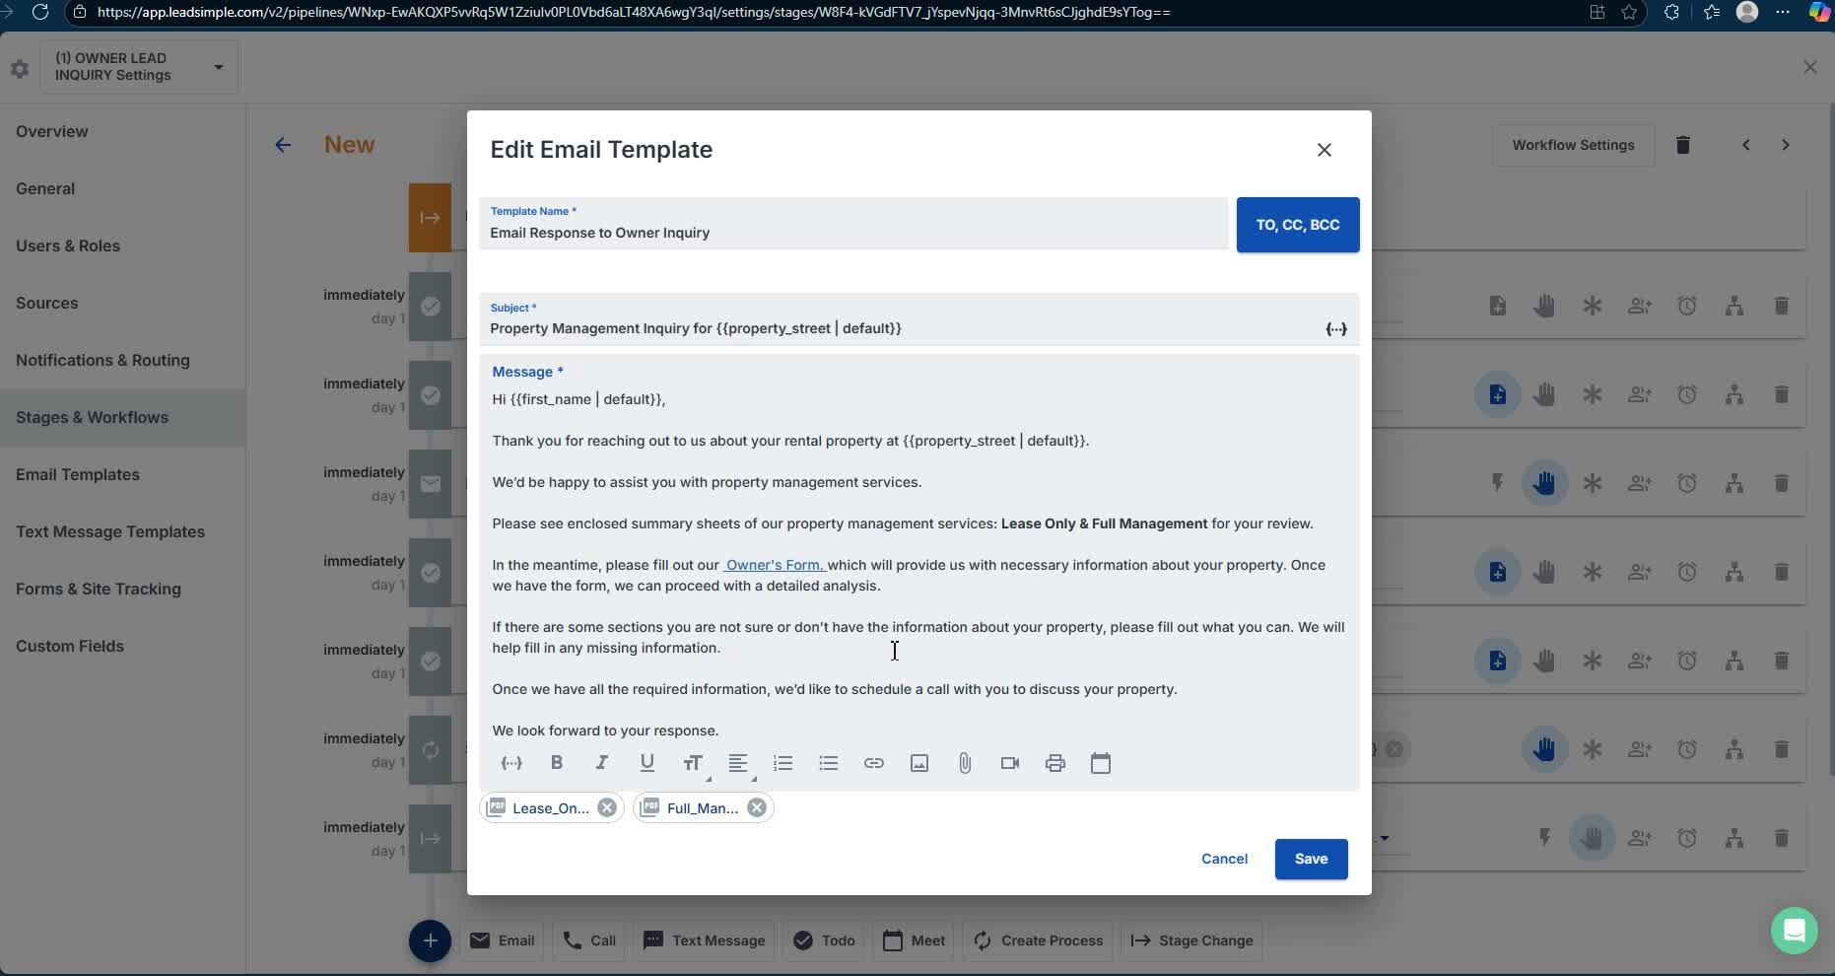
- Ensure all required fields are filled out to avoid submission issues.
- Assist owners in filling out the form if they encounter problems.

4. Tag Lead in Leadsimple 7:11

- Manually enter lead information into Leadsimple.

5. Schedule Property Meeting 11:09

- Arrange a meeting with the owner to visit the property.

6. Conduct Property Inspection 14:44
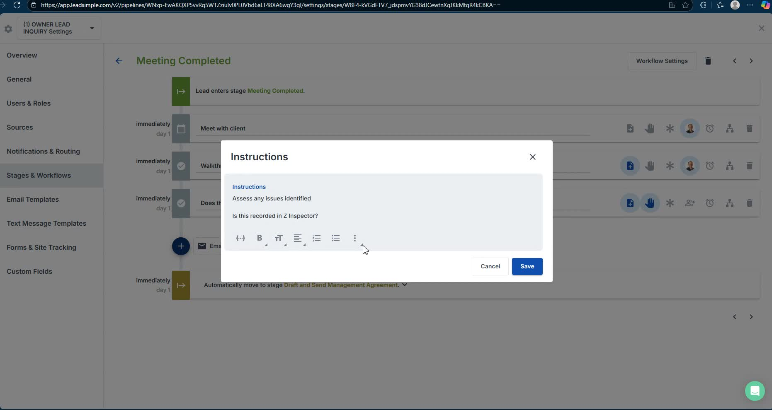
- Inspect plumbing, heating, and appliances during the visit.

7. Draft Management Agreement 15:50
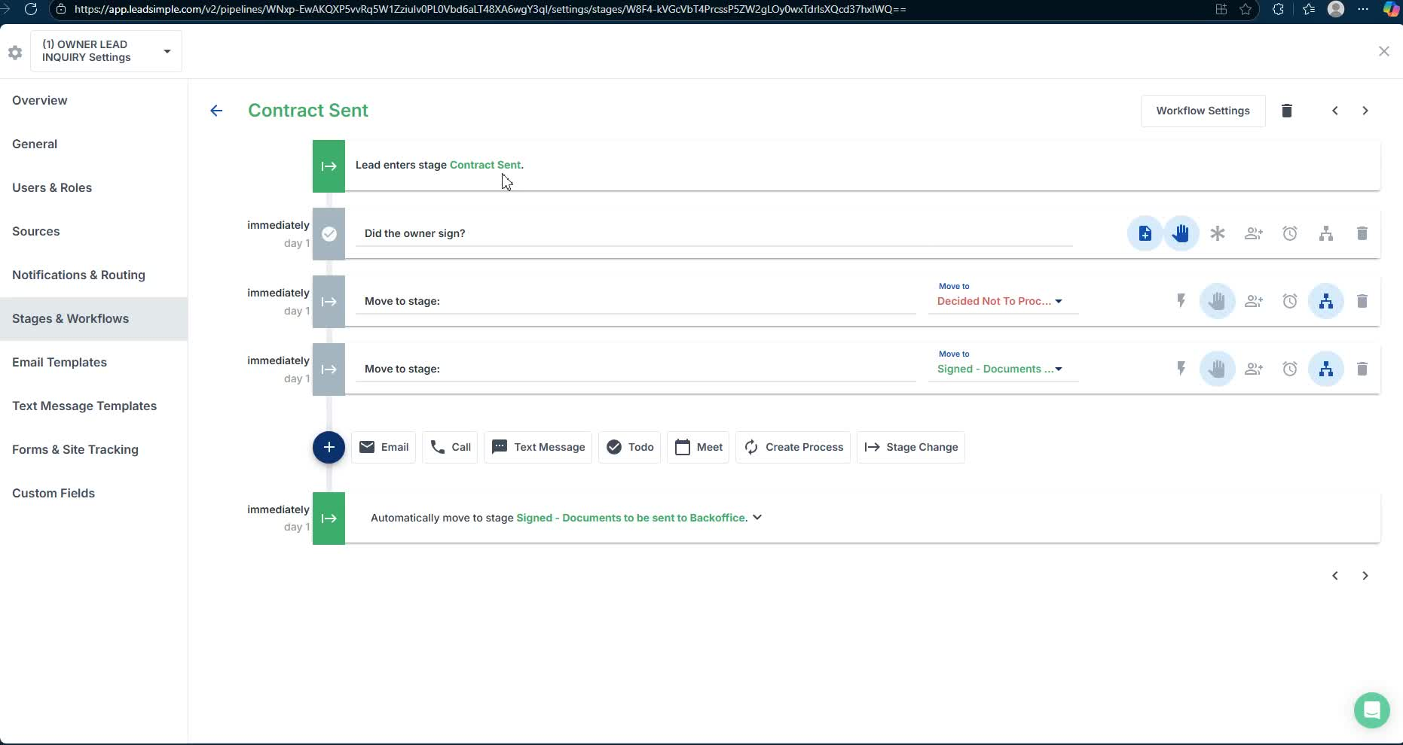
- Finalize and send the management agreement to the owner for signature.

8. Submit Documentation to Back Office 16:13

- Prepare and submit all necessary documents for setup in Yardie.

9. Handle Owner Decision 20:47

- If the owner decides not to proceed, document the reason in Leadsimple.
Link to Loom
https://loom.com/share/c2511769dbac458b9ef070f74291bd3c

